NETWORK CONFIGURATION AND SERVICES
Part 1; Configuring network interfaces and network settings
Viewing network interfaces use the command; nmcli device status
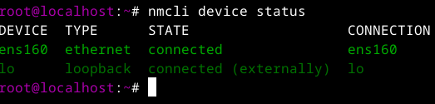
Viewing IP details use the command; nmcli device show devicename
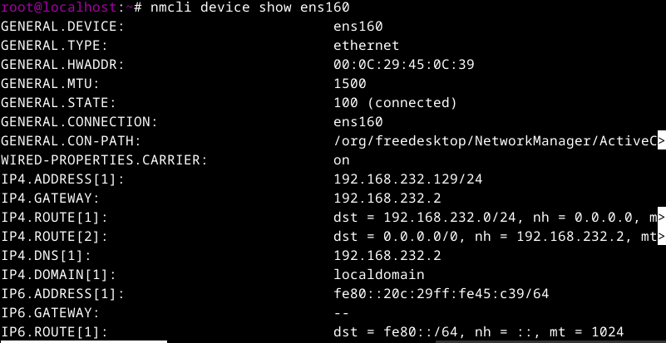
NOTE; We can also use the command; nmcli connection show to view network interfaces and the command; ip addr show to view IP details
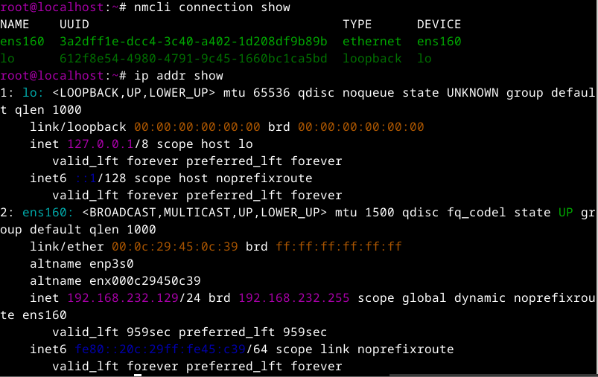
Viewing available connection files use the command; ls /NetworkManager/system-connections/
Editing available connection file use the command; nano /etc/NetworkManager/system-connections/filename
Part 2; DHCP server configuration and management
Installing the dhcp-server package use the command; sudo dnf install dhcp-server -y
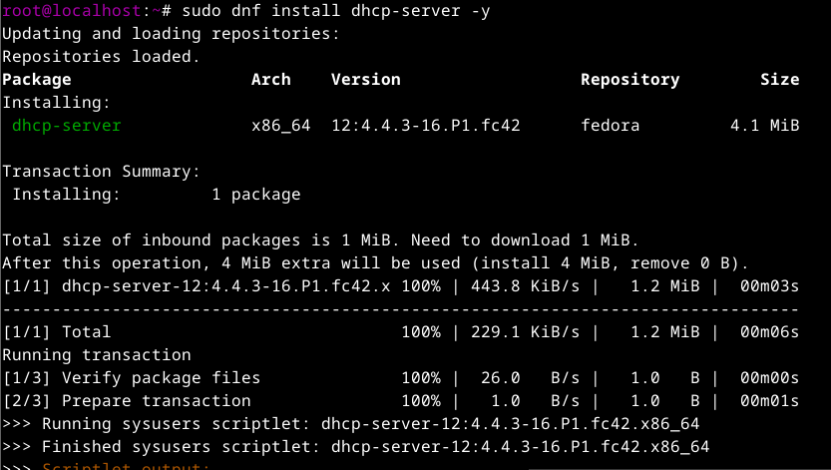
To confirm installation use the command; rpm -q dhcp-server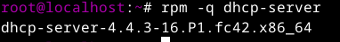
NOTE; The main configuration file for DHCP-Server is; /etc/dhcp/dhcpd.conf
To edit configuration file use the command; nano /etc/dhcp/dhcpd.conf
To view the content use the command ; cat /etc/dhcp/dhcpd.conf
Once configured, enable and start the DHCP service using the commands below:
- sudo systemctl enable dhcpd
- sudo systemctl start dhcpd
- sudo systemctl status dhcpd

Firewall Configuration-Allow DHCP traffic through the firewall to ensure proper communication with clients:
sudo firewall-cmd --add-service=dhcp --permanent
sudo firewall-cmd –reload
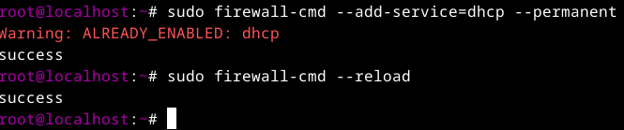

Part 3;DNS server setup using BIND
Install bind using the following command; sudo dnf install bind
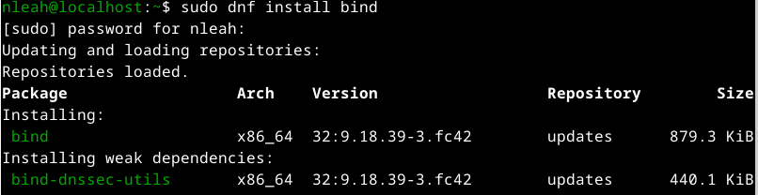
To edit configuration file use the command; nano /etc/named.conf
To edit zone file use the command; nano /var/named/zonefilename
NOTE; Configuration Files
The primary configuration file is /etc/named.conf. It contains global settings and includes zone
configurations. Zone files are stored in the /var/named/ directory by default.
Uncomment the listen-on line and add the IP address of your DNS server.
Uncomment the allow-query line and add the IP address range of your local network.
For example, if your DNS server has the IP address 192.168.1.10 and your local network is
192.168.1.0/24, the following configuration would be valid:
options {
listen-on port 53 { 192.168.1.10; };
allow-query { 192.168.1.0/24; };
To view the content use the command; cat /var/named/zonefilename
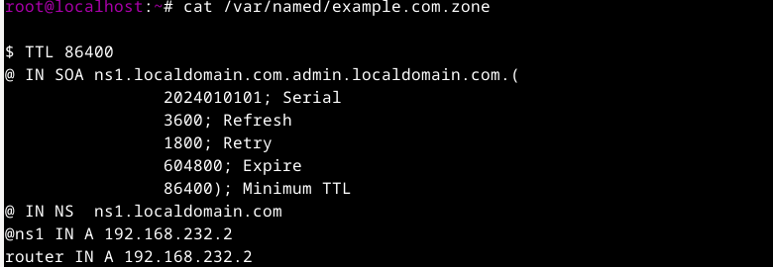
Start and Enable BIND use the command; sudo systemctl start named and sudo systemctl enable name
Test your DNS server configuration using the command; dig example.com
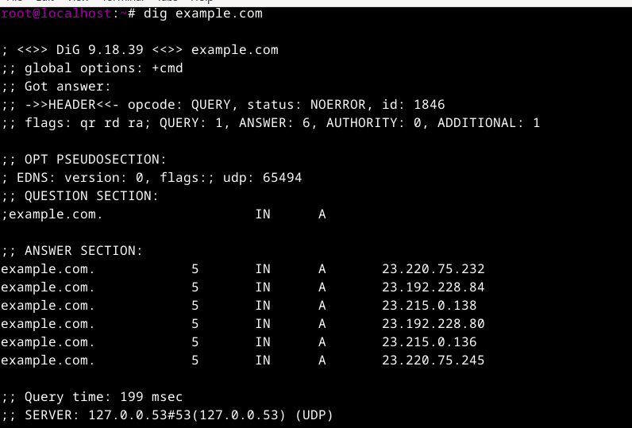
Part 4; Network time synchronization with NTP
To install the NTP package we use chrony hence the command; sudo dnf install chrony -y
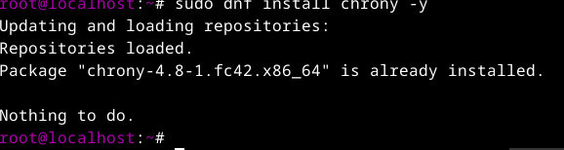
To check status after installation use the command; sudo systemctl status chronyd
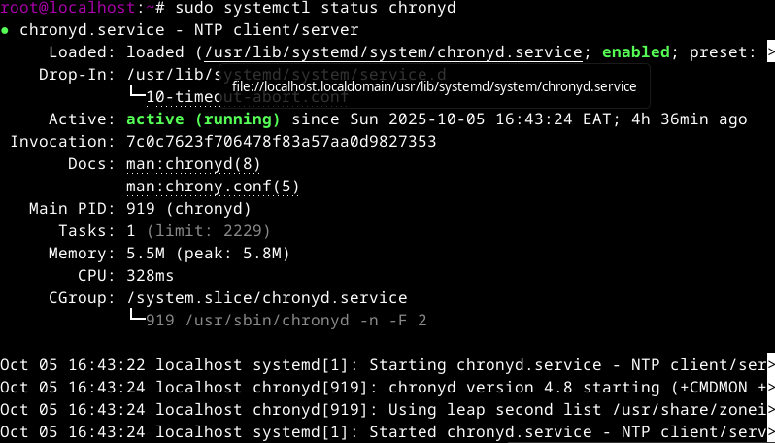
NOTE; The main configuration file is /etc/chrony.conf
To edit the configuration file use the command; nano /etc/chrony.conf
Start and Enable NTP use the command; sudo systemctl start chronyd and sudo systemctl enable chronyd
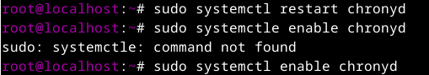
Firewall Configuration If you have the firewall enabled, allow NTP traffic through the command; sudo firewall-cmd --add-service=ntp --permanent and sudo firewall-cmd –reload
Verification Check the status of the NTP service to ensure it's running use the command; sudo systemctl status chronyd

